Formulation Development and Evaluation of Nanoparticles with Recombinant
Gupta A.K.*, Jain P.K.
Xyz institute of Pharmacy and science, followed by address
Email: email id of corresponding author

Received ….., Accepted for publication ……, Published …….
ABSTRACT
Sample text inserted for illustration. Replace with abstract text. Your abstract should give readers a brief summary of your article. It should concisely describe the contents of your article, and include key terms. It should be informative, accessible and not only indicate the general scope of the article but also state the main results obtained and conclusions drawn. The abstract should be complete in itself; it should not contain undefined abbreviations and no table numbers, figure numbers, references or equations should be referred to. It should be suitable for direct inclusion in abstracting services and should not normally be more than 200-250 words.
Keywords: Abc, Abc, Abc, Abc, Abc, Abc (6-10).

INTRODUCTION
Sample text inserted for illustration. Replace with article text, including headings where appropriate. Figures and tables can be single- or double-column width as appropriate. During the production process they will be placed at the top or bottom of columns, after they are first cited in the text. ^{[1]}
Lorem ipsum dolor sit amet, consectetuer adipiscing elit. Maecenas porttitor congue massa. Fusce posuere, magna sed pulvinar ultricies, purus lectus malesuada libero, sit amet commodo magna eros quis urna. Nunc viverra imperdiet enim. Fusce est. Vivamus a tellus. Pellentesque habitant morbi tristique senectus et netus et malesuada fames ac turpis egestas. Proin pharetra nonummy pede.^{[2-3]}
Mauris et orci. Aenean nec lorem. In porttitor. Donec laoreet nonummy augue. Suspendisse dui purus, scelerisque at, vulputate vitae, pretium mattis, nunc. Mauris eget neque at sem venenatis eleifend. Ut nonummy. Fusce aliquet pede non pede.^{[4]}
Classification of Antioxidants
Suspendisse dapibus lorem pellentesque magna. Integer nulla. Donec blandit feugiat ligula. Donec hendrerit, felis et imperdiet euismod, purus ipsum pretium metus, in lacinia nulla nisl eget sapien. Donec ut est in lectus consequat consequat. Etiam eget dui. Aliquam erat volutpat. Sed at lorem in nunc porta tristique.^{[5]}
Initial Antioxidants
Suspendisse dapibus lorem pellentesque magna. Integer nulla. Donec blandit feugiat ligula. Donec hendrerit, felis et imperdiet euismod, purus ipsum pretium metus, in lacinia nulla nisl eget sapien. Donec ut est in lectus consequat consequat. Etiam eget dui. Aliquam erat volutpat. Sed at lorem in nunc porta tristique.^{[6]}
Secondary Antioxidants
Suspendisse dapibus lorem pellentesque magna. Integer nulla. Donec blandit feugiat ligula. Donec hendrerit, felis et imperdiet euismod, purus ipsum pretium metus, in lacinia nulla nisl eget sapien. Donec ut est in lectus consequat consequat. Etiam eget dui. Aliquam erat volutpat. Sed at lorem in nunc porta tristique (Fig. 1).^{[7-8]}
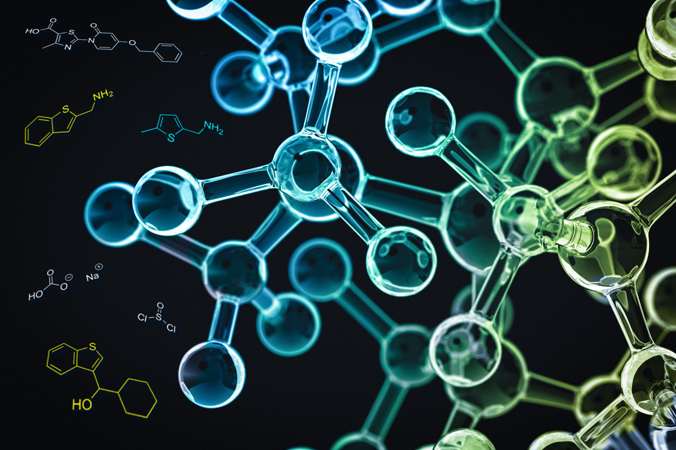
Fig. 1: Classification of Antioxidants^{[9]}
MATERIALS AND METHODS
Proin nec augue. Quisque aliquam tempor magna. Pellentesque habitant morbi tristique senectus et netus et malesuada fames ac turpis egestas. Nunc ac magna. Maecenas odio dolor, vulputate vel, auctor ac, accumsan id, felis. Pellentesque cursus sagittis felis. Pellentesque porttitor, velit lacinia egestas auctor, diam eros tempus arcu, nec vulputate augue magna vel risus. Cras non magna vel ante adipiscing rhoncus.^{[9]}
Formulation preparation
Vivamus a mi. Morbi neque. Aliquam erat volutpat. Integer ultrices lobortis eros. Pellentesque habitant morbi tristique senectus et netus et malesuada fames ac turpis egestas. Proin semper, ante vitae sollicitudin posuere, metus quam iaculis nibh, vitae scelerisque nunc massa eget pede. Sed velit urna, interdum vel, ultricies vel, faucibus at, quam. Donec elit est, consectetuer eget, consequat quis, tempus quis, wisi.Suspendisse dapibus lorem pellentesque magna. Integer nulla. Donec blandit feugiat ligula (Table 1).^{[7-10]}
Table 1: Formulation composition^{[11-12]}
S.No. | Ingredients | Quantity

RESULTS AND DISCUSSION
Donec hendrerit, felis et imperdiet euismod, purus ipsum pretium metus, in lacinia nulla nisl eget sapien. Donec ut est in lectus consequat consequat. Etiam eget dui. Aliquam erat volutpat. Sed at lorem in nunc porta tristique.
Nunc sagittis. Curabitur varius fringilla nisl. Duis pretium mi euismod erat. Maecenas id augue. Nam vulputate. Duis a quam non neque lobortis malesuada. Praesent euismod. Donec nulla augue, venenatis scelerisque, dapibus a, consequat at, leo.
Pellentesque libero lectus, tristique ac, consectetuer sit amet, imperdiet ut, justo. Sed aliquam odio vitae tortor. Proin hendrerit tempus arcu. In hac habitasse platea dictumst. Suspendisse potenti. Vivamus vitae massa adipiscing est lacinia sodales. Donec metus massa, mollis vel, tempus placerat, vestibulum condimentum, ligula. Nunc lacus metus, posuere eget, lacinia eu, varius quis, libero.^{[13-14]}
CONCLUSION
This section should give a brief recap of the issue examined, the method used and major finding(s), what are the implications of your work? How does it add to the literature? And describe how future researchers can expand or build on your work.
Conflicts of Interest: Authors declare no conflict of interest.
Acknowledgement
Those who have helped the authors carry out the study and/or prepare the manuscript but have not made a significant intellectual contribution to deserve authorship must be acknowledged
REFERENCES
- Singh SD, Gupta PA, John AL. Solid-dispersion manufacturing processes. Int J Pharm. 2002; 347(4): 284-7.
- Rose SE, Rubin J, Medick Q, Masion P, Jalmer MA, Chiding K, et al. Regulation of interstitial excitatory amino acid concentrations after cortical contusion injury. Drug Res. 2002; 935(1-2): 40-6.
- Akid S. Drug delivery research in herbal medicines. Am J Pharm [serial on the Internet]. 2002 Jun [cited 2002 Aug 12]; 102(6): [about 3 p.]. Available from: http://www.pharmaworld.org/AJN/2002.
- Gilstrap LC 3rd, Cunningham FG, Van Dorsten JP, editors. Operative obstetrics. 2nd ed. New York: McGraw-Hill; 2002.

